

Cyprus International University.
Faculty of Computer Engineering.
CMPE343 Database Management Systems and Programming-I

Project: Ercan Airport Management System.

Date: 17/05/2026

Group Members:
Eyad Al-Moaid 22321363 CMPE
Hasan Amer 22324331 CMPE
Osman Dilan 22110368 SWEN

Submitted to: Asst. Prof. Dr. Yasemin BAY

Introduction

Ercan Airport Management System is a fully MySQL-based database system that stores, manipulates and retrieves data of plane, flight, hangars and employees of its own. The system divides the employees into two parts, the technicians and the traffic controllers. Planes types, number, models’ numbers and models’ names are also stored in our database. There are some additional features like hangars, hangars history for in-n-out planes monitoring, and we also have maintenance and testing data stored for safety measurements.

ERD

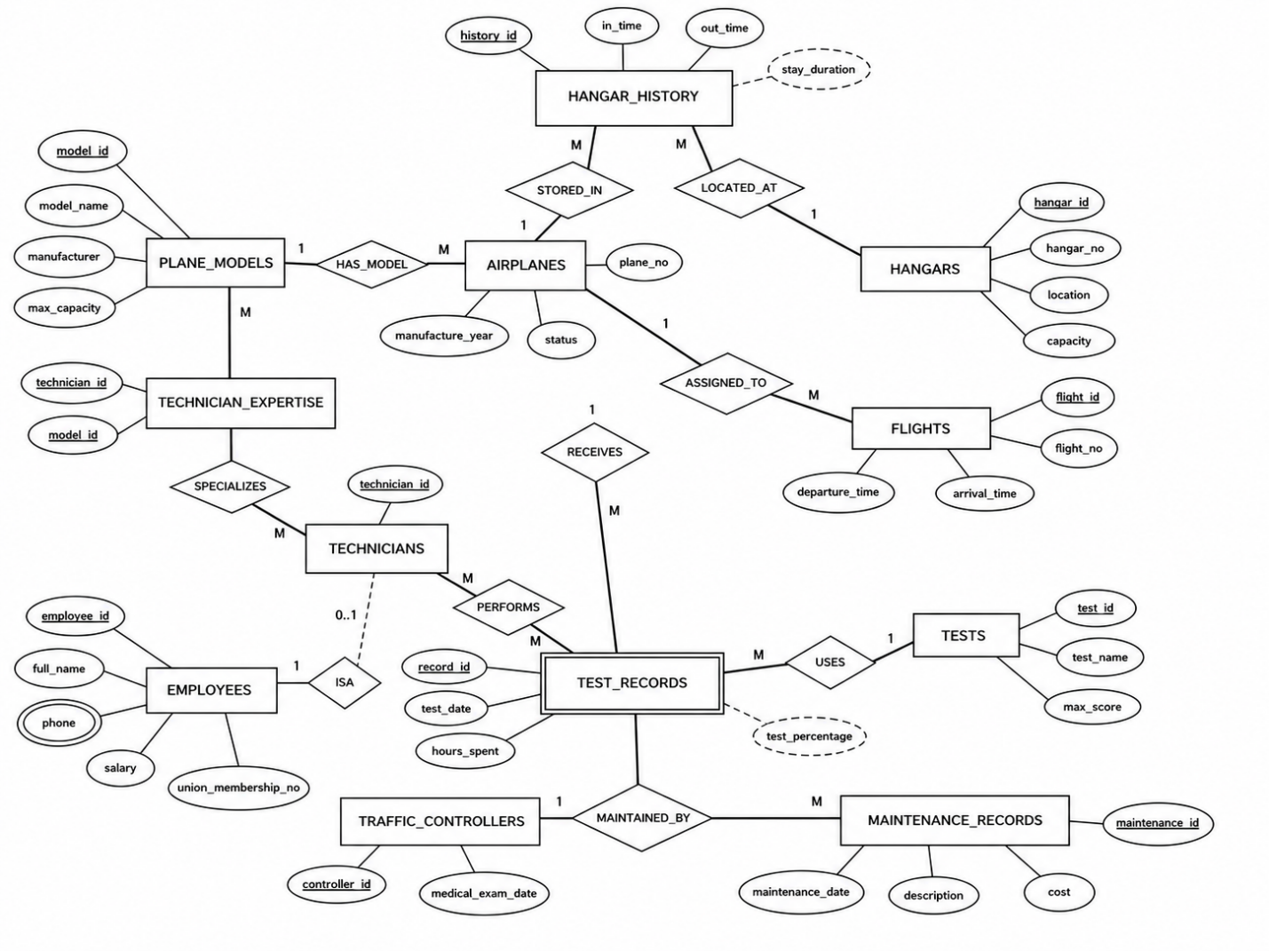

Relational Data Model
PLANE_MODELS(model_id PK,model_name,manufacturer,max_capacity)

AIRPLANES(plane_id PK,plane_no,model_id FK → PLANE_MODELS(model_id),manufacture_year,status)

HANGARS(hangar_id PK,hangar_no,location,capacity)

EMPLOYEES(employee_id PK,full_name,phone,salary,union_membership_no)

TECHNICIANS(technician_id PK,employee_id FK → EMPLOYEES(employee_id))

TRAFFIC_CONTROLLERS(controller_id PK,employee_id FK →EMPLOYEES(employee_id),medical_exam_date)

HANGAR_HISTORY(history_id PK,plane_id FK → AIRPLANES(plane_id),hangar_id FK → HANGARS(hangar_id),in_time,out_time)

TECHNICIAN_EXPERTISE(technician_id PK, FK → TECHNICIANS(technician_id),model_id PK, FK → PLANE_MODELS(model_id))

TESTS(test_id PK,test_name, max_score)

TEST_RECORDS(record_id PK,plane_id FK → AIRPLANES(plane_id),technician_id FK → TECHNICIANS(technician_id),test_id FK → TESTS(test_id),test_date,hours_spent,score)

FLIGHTS(flight_id PK,plane_id FK → AIRPLANES(plane_id),controller_id FK → TRAFFIC_CONTROLLERS(controller_id),flight_no,departure_airport,arrival_airport,departure_time,arrival_time)

MAINTENANCE_RECORDS(maintenance_id PK,plane_id FK → AIRPLANES(plane_id), technician_id FK → TECHNICIANS(technician_id),maintenance_date,description,cost)

DDL
CREATE TABLE plane_models (
model_id INT PRIMARY KEY,
model_name VARCHAR(100),
manufacturer VARCHAR(100),
max_capacity INT
);
CREATE TABLE airplanes (
plane_id INT PRIMARY KEY,
plane_no VARCHAR(20),
model_id INT,
manufacture_year INT,
status VARCHAR(50),
FOREIGN KEY (model_id) REFERENCES plane_models(model_id)
);
CREATE TABLE hangars (
hangar_id INT PRIMARY KEY,
hangar_no VARCHAR(20),
location VARCHAR(100),
capacity INT
);
CREATE TABLE employees (
employee_id VARCHAR(20) PRIMARY KEY,
full_name VARCHAR(100),
phone VARCHAR(20),
salary DECIMAL(10,2),
union_membership_no VARCHAR(50)
);

CREATE TABLE hangar_history (
history_id INT PRIMARY KEY,
plane_id INT,
hangar_id INT,
in_time DATETIME,
out_time DATETIME,
FOREIGN KEY (plane_id) REFERENCES airplanes(plane_id),
FOREIGN KEY (hangar_id) REFERENCES hangars(hangar_id)
);
CREATE TABLE technicians (
technician_id INT PRIMARY KEY,
employee_id VARCHAR(20),
FOREIGN KEY (employee_id) REFERENCES employees(employee_id)
);
CREATE TABLE tests (
test_id INT PRIMARY KEY,
test_name VARCHAR(100),
max_score INT
);
CREATE TABLE technician_expertise (
technician_id INT,
model_id INT,
PRIMARY KEY (technician_id, model_id),
FOREIGN KEY (technician_id) REFERENCES technicians(technician_id),
FOREIGN KEY (model_id) REFERENCES plane_models(model_id)
);

CREATE TABLE traffic_controllers (
controller_id INT PRIMARY KEY,
employee_id VARCHAR(20),
medical_exam_date DATE,
FOREIGN KEY (employee_id) REFERENCES employees(employee_id)
);
CREATE TABLE flights (
flight_id INT PRIMARY KEY,
plane_id INT,
controller_id INT,
flight_no VARCHAR(20),
departure_airport VARCHAR(100),
arrival_airport VARCHAR(100),
departure_time DATETIME,
arrival_time DATETIME,
FOREIGN KEY (plane_id) REFERENCES airplanes(plane_id),
FOREIGN KEY (controller_id) REFERENCES traffic_controllers(controller_id)
);
CREATE TABLE maintenance_records (
maintenance_id INT PRIMARY KEY,
plane_id INT,
technician_id INT,
maintenance_date DATE,
description TEXT,
cost DECIMAL(10,2),
FOREIGN KEY (plane_id) REFERENCES airplanes(plane_id),
FOREIGN KEY (technician_id) REFERENCES technicians(technician_id)
);

CREATE TABLE test_records (
record_id INT PRIMARY KEY,
plane_id INT,
technician_id INT,
test_id INT,
test_date DATE,
hours_spent DECIMAL(5,2),
score INT,
FOREIGN KEY (plane_id) REFERENCES airplanes(plane_id),
FOREIGN KEY (technician_id) REFERENCES technicians(technician_id),
FOREIGN KEY (test_id) REFERENCES tests(test_id)
);

DML
INSERT INTO plane_models VALUES
(1, 'Boeing 737', 'Boeing', 189),
(2, 'Airbus A320', 'Airbus', 180),
(3, 'Boeing 777', 'Boeing', 396),
(4, 'Airbus A330', 'Airbus', 300),
(5, 'Embraer E190', 'Embraer', 114),
(6, 'Cessna 172', 'Cessna', 4),
(7, 'Boeing 787', 'Boeing', 335),
(8, 'Airbus A350', 'Airbus', 350),
(9, 'Bombardier CRJ900', 'Bombardier', 90),
(10, 'ATR 72', 'ATR', 72);

INSERT INTO airplanes VALUES
(1, 'ERC101', 1, 2018, 'Active'),
(2, 'ERC102', 2, 2020, 'Maintenance'),
(3, 'ERC103', 3, 2016, 'Active'),
(4, 'ERC104', 4, 2019, 'Active'),
(5, 'ERC105', 5, 2021, 'Inspection'),
(6, 'ERC106', 6, 2015, 'Active'),
(7, 'ERC107', 7, 2022, 'Active'),
(8, 'ERC108', 8, 2023, 'Active'),
(9, 'ERC109', 9, 2017, 'Maintenance'),
(10, 'ERC110', 10, 2014, 'Active');

INSERT INTO hangars VALUES
(1, 'H1', 'North Zone', 5),
(2, 'H2', 'South Zone', 8),
(3, 'H3', 'East Wing', 6),
(4, 'H4', 'West Wing', 4),
(5, 'H5', 'Cargo Area', 10),
(6, 'H6', 'Repair Center', 7),
(7, 'H7', 'VIP Area', 2),
(8, 'H8', 'Maintenance Zone', 9),
(9, 'H9', 'Overflow Area', 12),
(10, 'H10', 'Remote Hangar', 3);

INSERT INTO employees VALUES
('EID101', 'Ahmed Hassan', '0551234567', 3500, 'UN1001'),
('EID102', 'Ali Salem', '0552223344', 4200, 'UN1002'),
('EID103', 'Murat Yildiz', '0553334455', 5000, 'UN1003'),
('EID104', 'Mohammed Yasin', '0554445566', 3900, 'UN1004'),
('EID105', 'Khaled Nasser', '0555556677', 4600, 'UN1005'),
('EID106', 'Arda Demir', '0556667788', 5200, 'UN1006'),
('EID107', 'Tariq Saleh', '0557778899', 4100, 'UN1007'),
('EID108', 'Yousef Ibrahim', '0558889900', 3700, 'UN1008'),
('EID109', 'Omar Khalil', '0559991122', 4800, 'UN1009'),
('EID110', 'Hakan Kaya', '0551112233', 5100, 'UN1010'),
('EID111', 'Ibrahim Mansour', '0552224455', 4700, 'UN1011');

INSERT INTO technicians VALUES
(1, 'EID101'),
(2, 'EID102'),
(3, 'EID104'),
(4, 'EID105'),
(5, 'EID106'),
(6, 'EID107'),
(7, 'EID108'),
(8, 'EID103');

INSERT INTO tests VALUES
(1, 'Engine Test', 100),
(2, 'Hydraulic Test', 100),
(3, 'Electrical Systems', 100),
(4, 'Landing Gear Check', 100),
(5, 'Fuel System Test', 100),
(6, 'Cabin Pressure Test', 100),
(7, 'Navigation Test', 100),
(8, 'Emergency Equipment Check', 100),
(9, 'Wing Structural Test', 100),
(10, 'Avionics Test', 100);

INSERT INTO hangar_history VALUES
(1, 1, 1, '2026-05-01 08:00:00', '2026-05-02 10:00:00'),
(2, 2, 2, '2026-05-02 09:00:00', NULL),
(3, 3, 3, '2026-05-03 10:00:00', '2026-05-04 12:00:00'),
(4, 4, 4, '2026-05-04 11:00:00', NULL),
(5, 5, 5, '2026-05-05 07:00:00', '2026-05-06 09:00:00'),
(6, 6, 6, '2026-05-06 08:30:00', NULL),
(7, 7, 7, '2026-05-07 09:15:00', '2026-05-08 11:45:00'),
(8, 8, 8, '2026-05-08 10:00:00', NULL);

INSERT INTO traffic_controllers VALUES
(1, 'EID109', '2026-03-15'),
(2, 'EID110', '2026-04-10'),
(3, 'EID111', '2026-02-20');

INSERT INTO maintenance_records VALUES
(1, 1, 1, '2026-05-01', 'Engine maintenance', 500.00),
(2, 2, 2, '2026-05-02', 'Hydraulic system check', 300.00),
(3, 3, 8, '2026-05-03', 'Electrical systems inspection', 400.00),
(4, 4, 3, '2026-05-04', 'Landing gear maintenance', 600.00),
(5, 5, 4, '2026-05-05', 'Fuel system maintenance', 700.00),
(6, 6, 5, '2026-05-06', 'Cabin pressure maintenance', 250.00),
(7, 7, 6, '2026-05-07', 'Navigation system repair', 450.00),
(8, 8, 7, '2026-05-08', 'Emergency equipment service', 350.00),
(9, 9, 1, '2026-05-09', 'Wing structure maintenance', 800.00),
(10, 10, 2, '2026-05-10', 'Avionics repair', 650.00);

INSERT INTO technician_expertise VALUES
(1, 1),
(1, 3),
(2, 2),
(2, 4),
(3, 5),
(3, 10),
(4, 6),
(5, 7),
(5, 8),
(6, 9),
(7, 1),
(7, 2),
(8, 3),
(8, 7);

INSERT INTO test_records VALUES
(1, 1, 1, 1, '2026-05-01', 2.5, 88),
(2, 2, 2, 2, '2026-05-02', 3.0, 76),
(3, 3, 8, 3, '2026-05-03', 2.0, 91),
(4, 4, 3, 4, '2026-05-04', 4.0, 84),
(5, 5, 4, 5, '2026-05-05', 1.5, 79),
(6, 6, 5, 6, '2026-05-06', 2.0, 95),
(7, 7, 6, 7, '2026-05-07', 3.5, 89),
(8, 8, 7, 8, '2026-05-08', 2.5, 92),
(9, 9, 1, 9, '2026-05-09', 4.5, 73),
(10, 10, 2, 10, '2026-05-10', 3.0, 86);

INSERT INTO flights VALUES
(1, 1, 1, 'ER1001', 'Ercan Airport', 'Istanbul Airport', '2026-05-01 09:00:00', '2026-05-01 10:30:00'),
(2, 2, 2, 'ER1002', 'Ercan Airport', 'Ankara Esenboga', '2026-05-02 11:00:00', '2026-05-02 12:20:00'),
(3, 3, 3, 'ER1003', 'Ercan Airport', 'London Heathrow', '2026-05-03 08:30:00', '2026-05-03 13:30:00'),
(4, 4, 1, 'ER1004', 'Ercan Airport', 'Dubai International', '2026-05-04 14:00:00', '2026-05-04 18:00:00'),
(5, 5, 2, 'ER1005', 'Ercan Airport', 'Antalya Airport', '2026-05-05 16:00:00', '2026-05-05 17:10:00'),
(6, 6, 3, 'ER1006', 'Ercan Airport', 'Izmir Adnan Menderes', '2026-05-06 07:45:00', '2026-05-06 09:00:00'),
(7, 7, 1, 'ER1007', 'Ercan Airport', 'Frankfurt Airport', '2026-05-07 10:15:00', '2026-05-07 14:00:00'),
(8, 8, 2, 'ER1008', 'Ercan Airport', 'Paris Charles de Gaulle', '2026-05-08 13:20:00', '2026-05-08 17:10:00'),
(9, 9, 3, 'ER1009', 'Ercan Airport', 'Beirut Airport', '2026-05-09 12:00:00', '2026-05-09 13:00:00'),
(10, 10, 1, 'ER1010', 'Ercan Airport', 'Cairo Airport', '2026-05-10 15:30:00', '2026-05-10 17:20:00');

Queries
--1)Display Plane Number and Model Name of all airplanes in the database.
SELECT a.plane_no , pm.model_name
FROM airplanes a
JOIN plane_models pm ON a.model_id = pm.model_id;
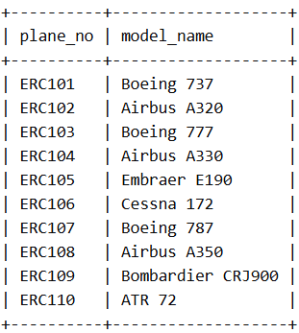
--2)List the full names and phone numbers of all employees who are technicians.
SELECT e.full_name, e.phone
FROM employees e
JOIN technicians t ON e.employee_id = t.employee_id;
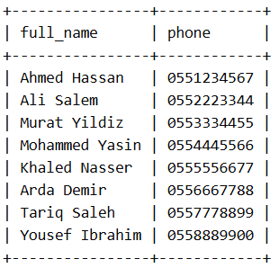
--3)List the full name and phone number of all employees who are traffic controllers.
SELECT e.full_name, e.phone
FROM employees e
JOIN traffic_controllers tc ON e.employee_id = tc.employee_id;
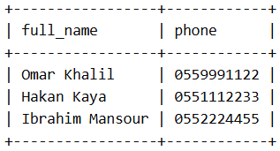
--4)List Model Name and Hnager Number of all planes that are currently in a hangar.
SELECT pm.model_name, h.hangar_no
FROM airplanes a
JOIN plane_models pm ON a.model_id = pm.model_id
JOIN hangar_history hh ON a.plane_id = hh.plane_id
JOIN hangars h ON hh.hangar_id = h.hangar_id
WHERE hh.out_time IS NULL;
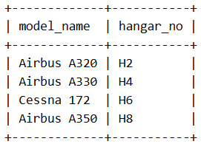
--5)List the full name of all technicians who have expertise in the plane model with the highest maximum capacity.
SELECT e.full_name
FROM employees e
JOIN technicians t ON e.employee_id = t.employee_id
JOIN technician_expertise te ON t.technician_id = te.technician_id
JOIN plane_models pm ON te.model_id = pm.model_id
WHERE pm.max_capacity = (SELECT MAX(max_capacity) FROM plane_models);
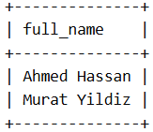
--6)Display every record of flights in the database.
SELECT *
FROM flights;
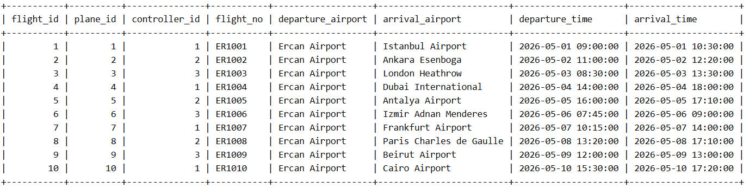
--7) List the Model name of planes with a score of 85 or higher in any test.
SELECT DISTINCT d.model_name
FROM plane_models d
JOIN airplanes a ON d.model_id = a.model_id
JOIN test_records tr ON a.plane_id = tr.plane_id
WHERE tr.score >= 85;
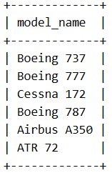
--8) List Employess with salary higher than 5000.
SELECT full_name, salary
FROM employees
WHERE salary > 5000;
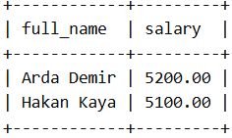
--9) List Full names of traffic controllers who have had a medical exam in the last 6 months.
SELECT e.full_name
FROM employees e
JOIN traffic_controllers tc ON e.employee_id = tc.employee_id
WHERE tc.medical_exam_date >= DATE_SUB(CURDATE(), INTERVAL 6 MONTH);
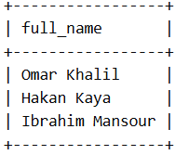
--10) List the full names of technicians who have expertise in the plane model with the lowest maximum capacity.
SELECT e.full_name
FROM employees e
JOIN technicians t ON e.employee_id = t.employee_id
JOIN technician_expertise te ON t.technician_id = te.technician_id
JOIN plane_models pm ON te.model_id = pm.model_id
WHERE pm.max_capacity = (SELECT MIN(max_capacity) FROM plane_models);
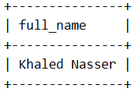
--11) Display the test that took more than 3 hours and had a score less than 80.
SELECT t.test_name, tr.hours_spent, tr.score
FROM tests t
JOIN test_records tr ON t.test_id = tr.test_id
WHERE tr.hours_spent > 3 AND tr.score < 80;
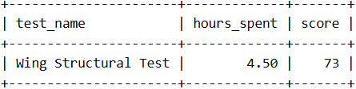
--12) List the flights that took more than 5 hours.
SELECT flight_no, departure_time, arrival_time,
TIMESTAMPDIFF(HOUR, departure_time, arrival_time) AS flight_time_hours
FROM flights
WHERE TIMESTAMPDIFF(HOUR, departure_time, arrival_time) > 3;
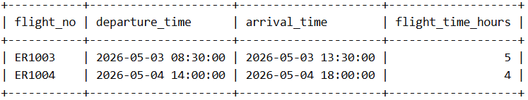
--13) Display the hangar with the biggest capacity.
SELECT hangar_no, capacity,location
FROM hangars
WHERE capacity = (SELECT MAX(capacity) FROM hangars);
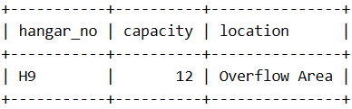
--14) Display the full name of the traffic controller who controlled the flight with the longest duration.
SELECT e.full_name, f.flight_no, TIMESTAMPDIFF(HOUR, f.departure_time, f.arrival_time) AS flight_duration_hours
FROM employees e
JOIN traffic_controllers tc ON e.employee_id = tc.employee_id
JOIN flights f ON tc.controller_id = f.controller_id
ORDER BY flight_duration_hours DESC
LIMIT 1;
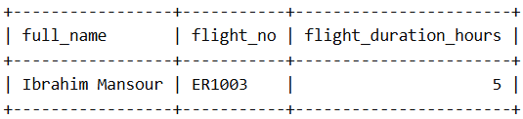
--15) Display the full name of the technician who performed the most maintenance records.
SELECT e.full_name, COUNT(m.maintenance_id) AS maintenance_count
FROM employees e
JOIN technicians t ON e.employee_id = t.employee_id
JOIN maintenance_records m ON t.technician_id = m.technician_id
GROUP BY e.full_name
ORDER BY maintenance_count DESC
LIMIT 1;
